IP Camera User Manual
(Web Browser)

Document Version: V1.3

Release Date: 2015/12

Menu
1 Camera Login and ActiveX Installation 4
1.1 Login Camera 4
1.2 Download the video ActiveX 4
1.3 ActiveX Installation 5
2 Preview Interface 7
2.1 Main Menu 8
2.2 Language 8
2.3 Video Stream Configuration 9
2.4 Stream Channel 9
2.5 Camera Info 9
2.6 Live view 9
2.7 OSD Buttons 9
2.7.1 Video Set Window 10
2.7.2 Snapshot and Record Settings 13
2.8 Video ActiveX 15
3 Playback Interface 15
3.1 Date Window 16
3.2 Records List 16
3.3 Playback Control Bar 17
3.4 Timeline of the records playing 17
4 Settings Interface 18
4.1 Basic Settings 18
4.1.1 Time 18
4.1.2 Users 19
4.1.3 TCP/IP 19
4.1.4 Port 20
4.1.5 Audio 20
4.1.6 Video Stream 21
4.1.7 System 23
4.1.8 Maintenance 24
4.2 System 24
4.2.1 Time 25
4.2.2 System Info 25
4.2.3 Maintenance 25
4.2.4 Alarm 25
4.2.5 System Status 25
4.3 Network 26
4.3.1 TCP/IP 26
4.3.2 Port 26
4.3.3 WIFI 26
4.3.4 FTP 27
4.3.5 PPPoE 28
4.3.6 SMTP 28
4.3.7 UPnP 29
4.3.8 RTSP 30
4.3.9 RTMP 30
4.4 Audio & Video 31
4.4.1 Audio 31
4.4.2 Video Stream 31
4.4.3 Image Setting 31
4.4.4 Privacy Mask 33
4.4.5 Video Shield 33
4.4.6 Motion Detection 34
4.4.6 ROI 34
4.5 Storage 35
4.5.1 SD Card 35
4.5.2 Record 35
4.6 Event 36
4.6.1 Event Type 36
4.6.3 Schedule Record 37
4.6.4 Schedule Upload 37
4.6.5 Schedule Snapshot 38
4.7 Safety 38
4.7.1 Users 38
4.7.2 IP Filtering 39
4.8 Log 39
4.8.1 Log Settings 39
4.8.2 Log Info 40

1 Camera Login and ActiveX Installation

1.1 Login Camera
Before logging in the camera, you have to revise the IP address of the PC to keep the same IP segment as the IP address of the cameras. The default IP address of the camera is 192.168.1.120, so the IP address of the PC should be 192.168.1.xxx, xxx should be not 1 and 120.
And now fill out the IP address of the camera like http://192.168.1.120 in Internet Explorer or other browsers like Firefox, Chrome and Safari etc. The authentication window will be promoted, and fill out the username (default is admin) and the password (default is 12345).
Internet Explorer example:

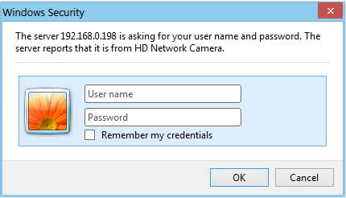

Fireforx or Chrome example:

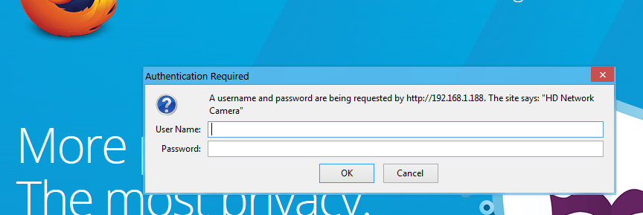

1.2 Download the video ActiveX
If it’s the first time to access the cameras using Internet Explorer, there will be no video and there is the notification to ask you to install the video like the below. If you access the cameras using Firefox, Chrome or Safari browsers, it’s no need to install the ActiveX but Adobe Flash plug-ins.
Internet Explorer example:
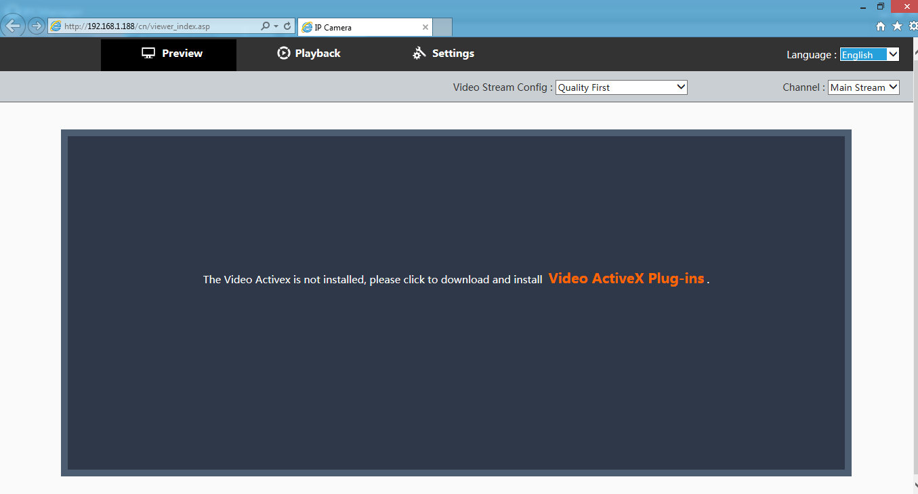Please download the ActiveX plug-ins and install it.
Firefox or Chrome example:
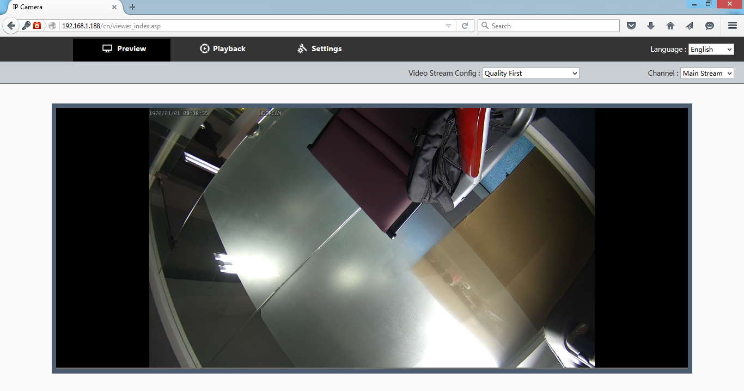
NOTED: If there is the difficulty to download the ActiveX automatically, you can copy or download the separated ActiveX setup software from the CD or the website. Otherwise please ask it from our sales directly.

1.3 ActiveX Installation
Click and save the ActiveX Plug-ins, and install it as the below procedures like the below:
（1）Click the executive file “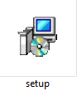”,
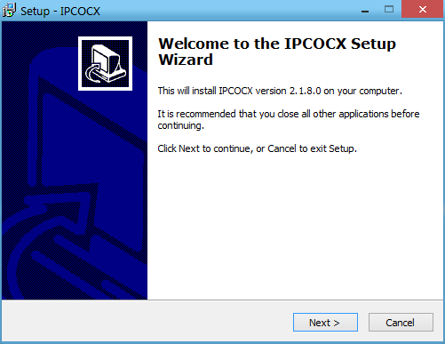

（2）Click “Next”.
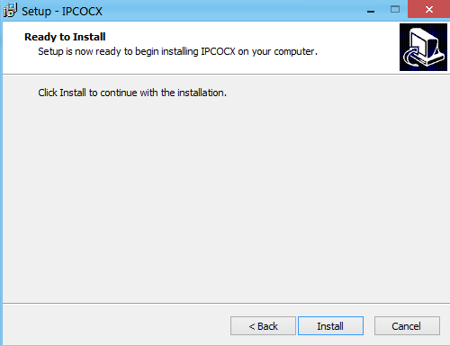
（3） Click “Next”,
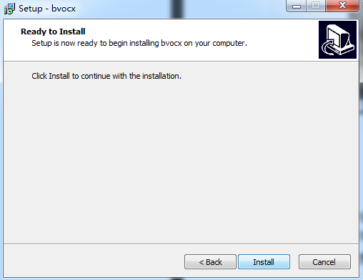

（4）Click “Install”,
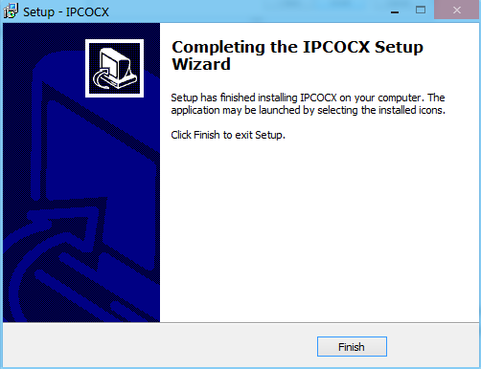

（5）Click “Finish”, the ActiveX plug-in will be installed successfully. And now refresh the IE, and video in Preview window will show you up.

2 Preview Interface
The IE preview interface contains 7 zones as below:
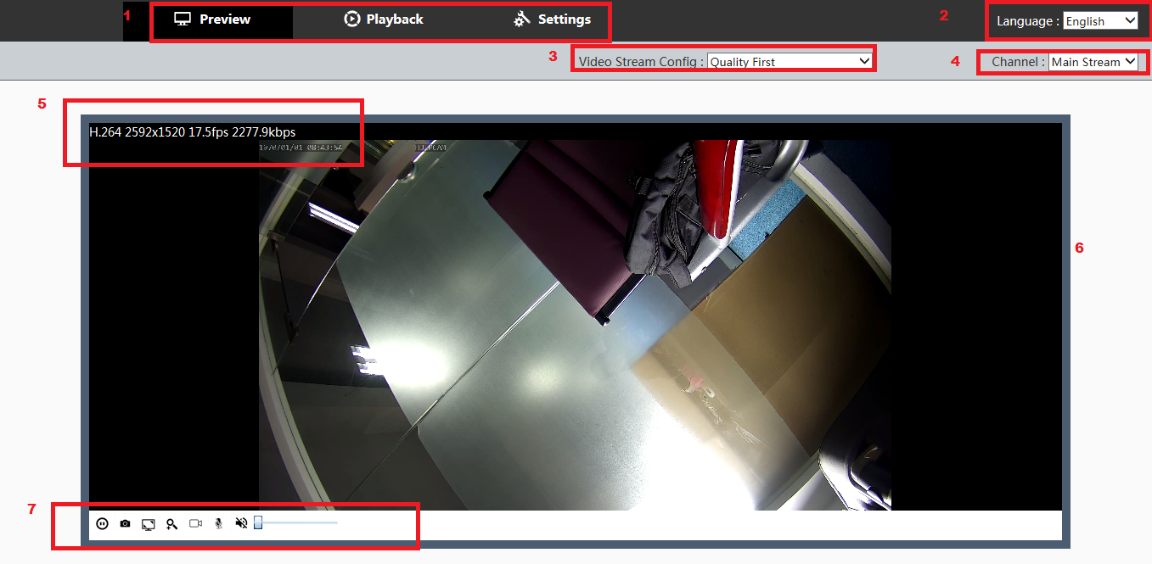

1 | Main menu | 5 | Camera info
2 | Language | 6 | Live view
3 | Video stream config. | 7 | OSD buttons
4 | Stream channel

2.1 Main Menu
The main menu contains 2 parts:
- Preview: the main interface to do live view.
- Playback: to playback the SD records in the camera which is only valid for the camera with the SD inserted.
- Settings: to set parameters of system, network, video& audio, storage, event, safety, log, and do maintenance such as resetting to default and upgrading.

2.2 Language

There is the language option for your selection. Now there are the Chinese, English, Russia, Italia, Greece and Vietnam supported, the language is also supported customization for the customers.
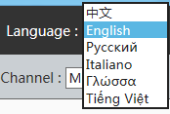

2.3 Video Stream Configuration

Concerning video stream configuration, there are 4 options for users:
- Quality first: It can ensure the quality of video and occupy more bandwidth;
- Bandwidth Quality Balance: It can provide high quality picture based on certain band width;
- Bandwidth First: It can ensure the smooth streaming of video;
- Mobile Devices: It’s used for mobile devices to view video image.
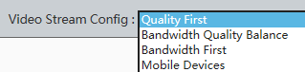

2.4 Stream Channel
It provides 2 kinds of video streams:
- Main stream: with resolution 720P, 1080P or higher;
- Sub stream: with resolution D1 (704*576), VGA (640*480), CIF (352*288) and QVGA (320*240).
Quick way to optimize picture quality display: select “Video Stream Config: Quality First” and “Chanel: Main Stream”. For video stream parameters settings, please refer to Chapter 2.4.2.
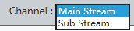

2.5 Camera Info
It provides overlapping displayed the camera name, encode type, resolution, frame rate, transmission speed, date & time, other customized text and image information. For camera info setting, please refer to Chapter 2.1.6.1 Common and 2.1.8 Maintenance -General.

2.6 Live view
It’s used to display current camera image.

2.7 OSD Buttons
You can set basic functions by clicking relative buttons.
: Play/ Stop preview. Video transmission will stop after clicking this button and no live video will show. Video transmission will return to normal after clicking the button again.
: Snap the current image.
: Enter/Exit Full-screen display mode. You can also double click the image to enter/exit full screen display.
: Digital Zoom
: Start/Stop Record
: Turn on / Turn off interphone
: Turn on / Turn off Speaker
Volume Control

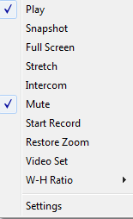
Users also can right click on the live preview screen to get following menu:
Area Zoom
Menu | Description
Play | Play/Stop preview
Snapshot | Snapshot
Full Screen | Enter/Exit full screen
Stretch | Stretch/Shrink the screen
Intercom | Start/Stop interphone
Mute | Enable/Disable audio
Start Record | Start/Stop record
Area Zoom | Area zoom/Restore Zoom
Video Set | Open Video Set window
W-H Ratio | Width Height ratio, default /4:3/16:9 optional
Settings | Open Settings window

2.7.1 Video Set Window
You can select “Video Set” tag on menu list of preview screen to enter video set panel shown as below image.
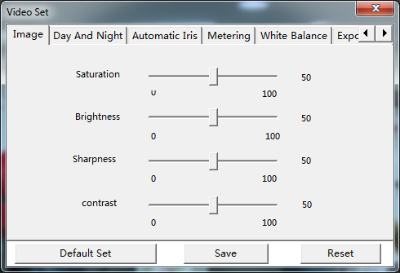
Default Set: click this button to get the Video Set default settings.
Save: click this button to save your changes.
Reset: click this button to abandon your changes.
Image:
Saturation: 0-100 configurable
Brightness: 0-100 configurable
Sharpness: 0-100 configurable
Contrast: 0-100 configurable
Day and Night:
Auto: Day/night switch automatically
Color: always keep color image.
Black and white: always keep black and white image
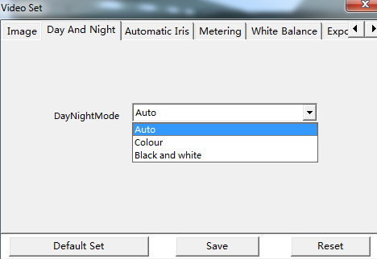
Automatic Iris
Iris control: Disable/Enable optional
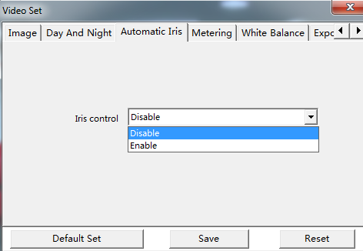
Metering:
Meter Mode: Global/Center optional
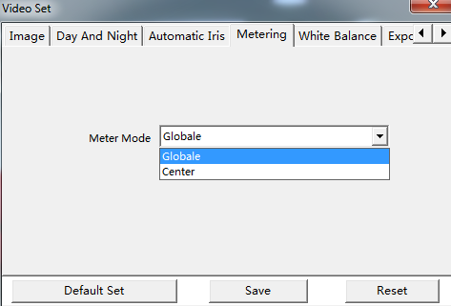
White Balance:
White Balance: Outdoors/Indoor/Fluorescent lamp/Manual
Red Gain & Blue Gain: 0-100 configurable
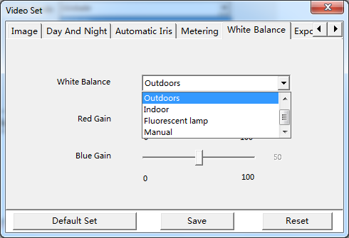
Exposure:
BLC: Disable/Enable optional
WDR: Disable/Enable optional
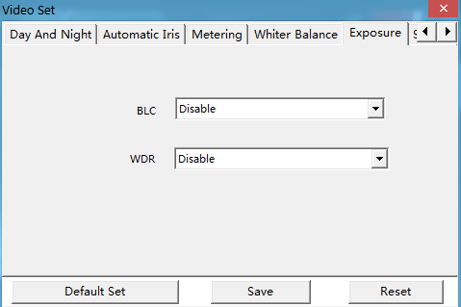
Shutter:
Max shutter: 1/2, 1/4, 1/8, 1/10, 1/12,1/15, 1/25(50hz)1/30(60hz), 1/50(50hz)1/60(60hz), 1/100(50hz)1/120(60hz), 1/125, 1/200, 1/500, 1/1000 optional.
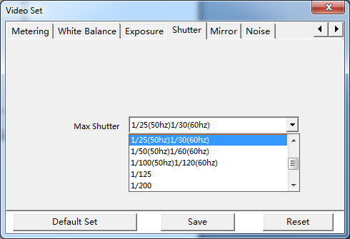
Mirror:
Image Mirror: None, Vertical, Horizontal, Vertical Horizontal optional.
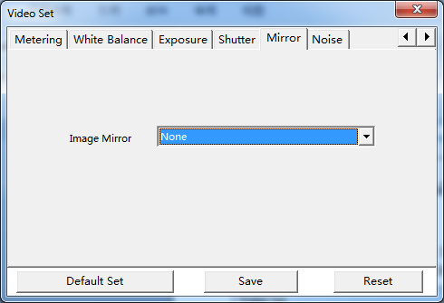
Noise:
Denoise: 0-100 configurable
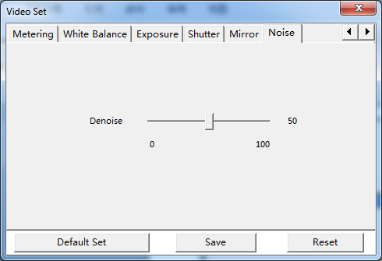
Advanced:
Defog: Disable or Enable.
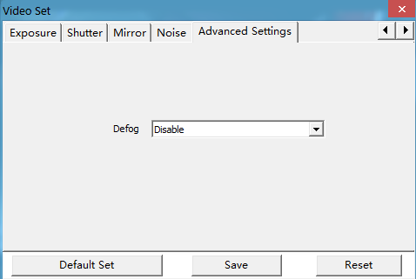

2.7.2 Snapshot and Record Settings
Click Settings tag on menu list of preview screen to enter settings panel, shown as below image.
General: Program’s general information is listed here.
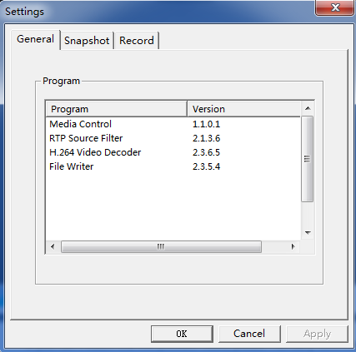
Snapshot: Change snapshot’s basic setting here.
Click Browse to select a path to save snapshots.
Response: When capture picture, enable/disable Open the snapshot, Popup message. When errors occurred, enable/disable Popup message.
Snapshot type: BMP or JPEG.
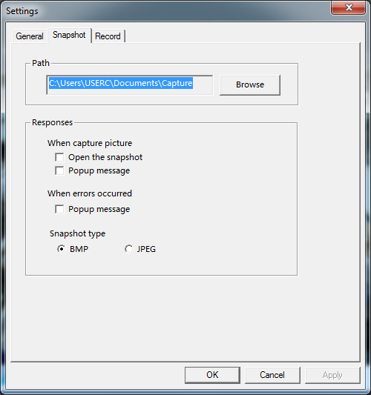
Record:
Save as: click Browse to select a path to save the recorded files.
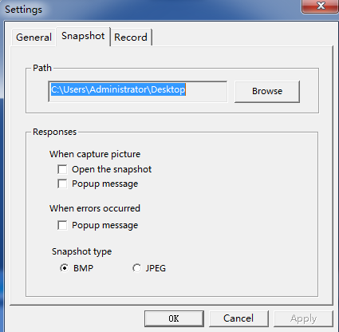

2.8 Video ActiveX
If there is no video automatically, please manually download Video ActiveX which is also located in the CD together with the camera in the package.
Please enable of functions under ActiveX controls and plug-ins on “Internet Options” interface if ActiveX downloading fails.
On “Internet Options” interface, click “Custom level” button to enter into “Security Settings-Internet Zone”, then enable all of functions under ActiveX controls and plug-ins.

3 Playback Interface
Click “Playback” button, and come to playback the records in SD card if the camera supports SD slot and has already SD card inserted.
Note: The user should install the ActiveX, and Playback is only valid in Internet Explorer.
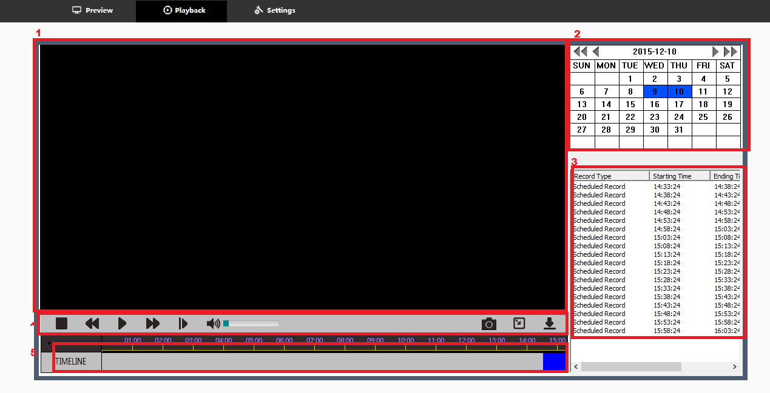

1 | Video window | The records is playing in the window.
2 | Date | The searched Date, if there is the records, the date will be marked as the blue.
3 | Records List | The records list will be shown if the date with the blue marked is selected.
4 | Playback Control bar | It’s the records play control button bar.
5 | TimeLine | The time line show the records play progress, and you can select each position for the records to play from.

3.1 Date Window
The date windows includes:
- 1: previous year. 2: Previous month; 3: Current Year-Month-Day;4: Next month; 5: Next Year
- 6: the blue marked date means there is the records in SD card.
- The user can click the blue marked date, and the records list will be shown in the Records list window.
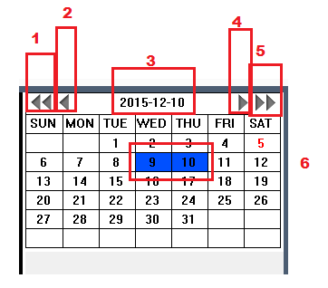

3.2 Records List

The records list is the selected date.
- Record Type: scheduled record or alarm triggered records.
- The records starting time
- The records ending time
- Total Schedule
The user can double click on the each item to playback the record.

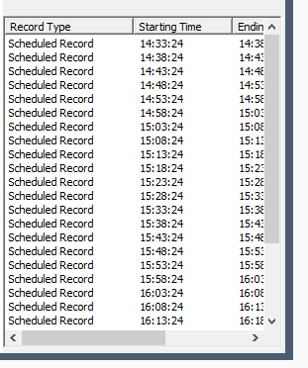
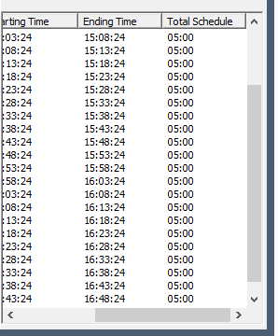

3.3 Playback Control Bar

Here is the playback control bar button definition:
- Stop: stop the playback;
- Slow play: 1/2,1/4,1/8 speed to playback the records;
- Play: start to playback the records;
- Quick play: X2,X4,X8 speed to playback the records;
- Pause: pause the play.
- Audio: adjust the audio volume when the records is playing back and the records has the audio.
- Snapshot: To snapshot when the records is playing
- Full screen: play the records in full screen.
- Download the records: it’s to download the current playing records.

3.4 Timeline of the records playing
The user can select the start time through clicking on the any time he has interest. The blue mean there is the records.
- ←→ >------< : enlarge and shorten the timeline
- Timebar: the time of the record is now playing.

4 Settings Interface
Click Setting on the screen to enter Setting interface.
Users can make basic settings, set parameters of system, network, video& audio, storage, event, safety, log, and do maintenance such as resetting to default and upgrading.
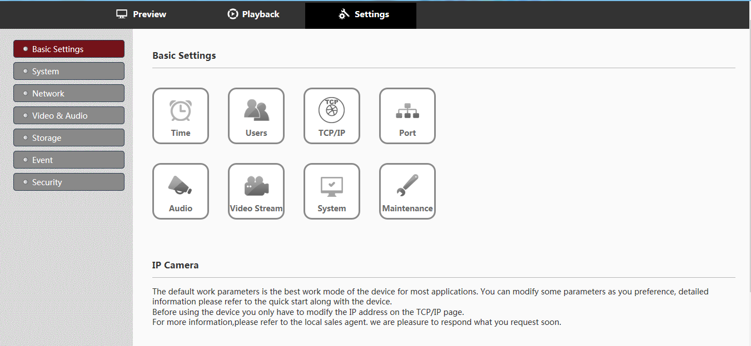

4.1 Basic Settings
There are 8 quick access icons for basic settings, as above image shown:
Click each icon to enter corresponded menu page.

4.1.1 Time
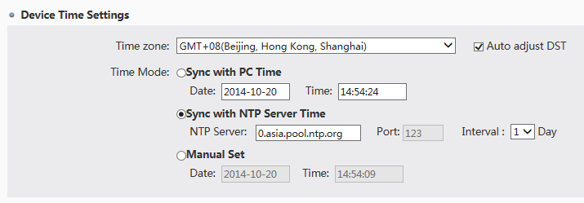
Choose time zone according to requirements. “Auto adjust DST” can be enabled.
There are three time modes optional:
- Sync with PC time.
- Sync with NTP server time: please fill in the right info about NTP server address and port, and set 1 to 5 days as interval.
- Manual Set: you can set time manually.
Device time will show on the upper left corner of preview interface after saved.

4.1.2 Users

4.1.2.1 User List
Existing user List shows as below. There are max. 15 users including admin.
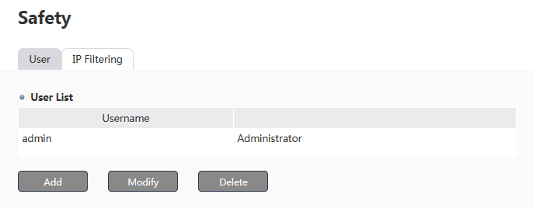

4.1.2.2 User configuration
Add user: click “add” button and fill in user name, password, and confirm password in the pop-up window. Set it as role administrator, operator, or viewer. Different roles have different authority. No upgrading and user management authority for operators. Only log & report authority for viewers.
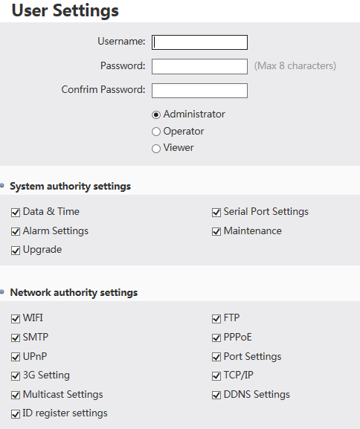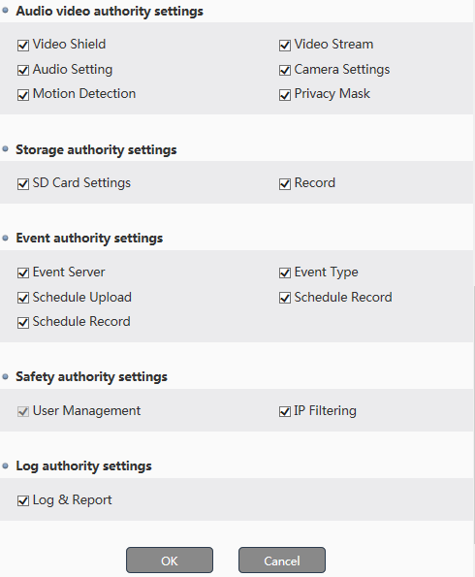
Edit User: select the user and click edit, then change its password and authority. For the default user admin, only password can be changed.
Delete User: select the user and click delete, then it will be deleted. The default user admin can’t be deleted.

4.1.3 TCP/IP
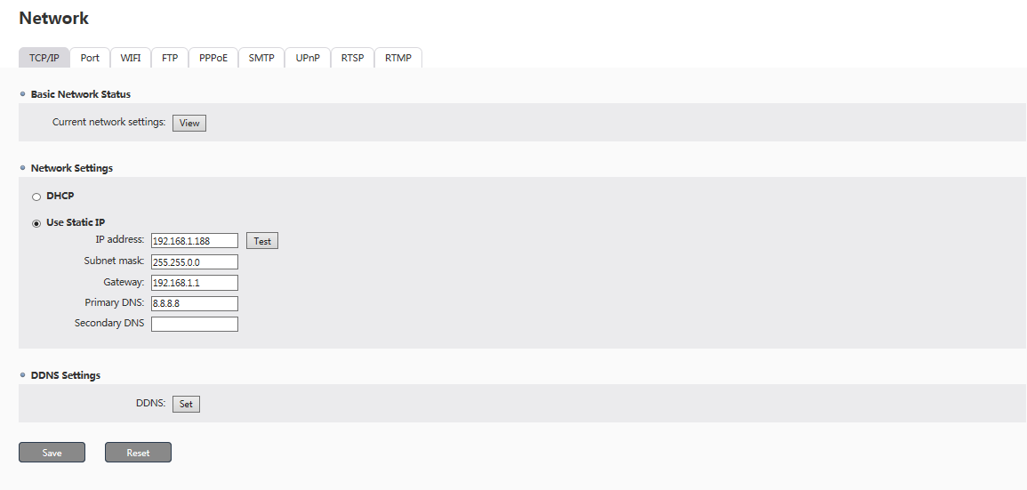
Basic Network Status:
Click View to see your network camera’s current network settings.
Network Settings:
DHCP: Click the checkbox of DHCP to enable this function.
USE Static IP: Click the checkbox of Use Static IP to enable this function, and then input its IP address, Subnet mask, Gateway, Primary DNS and Secondary DNS.
The camera will restart after changing its IP address.
DDNS Settings:
Click Set to change your DDNS settings.

4.1.4 Port
Http port, RTSP port and TCP port are available for changing.
Http port: 10000..50000, default is 80.
RTSP port: 10000..50000, Default is 554
TCP port: 10000..50000, Default is 6000.
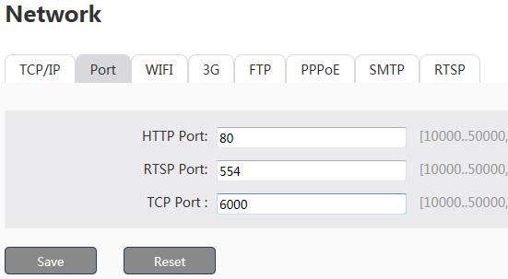

4.1.5 Audio
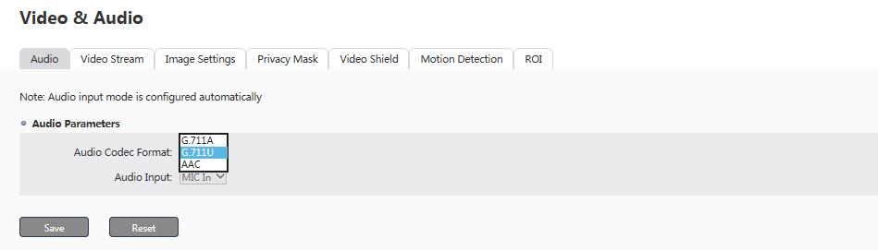
Audio codec format: G.711A, G.711U and AAC. The web will be refreshed when you chaned the audio codec format and save it.
Audio Input: Line-in or MIC. Microphone input will work if the camera hardware supports it.
Click Save to save your settings or click reset, to do settings again.

4.1.6 Video Stream
There are three tabs for video stream settings: common, video stream and MJPEG.

4.1.6.1 Common
Image mirror: Users can do horizontal mirror and vertical mirror.
OSD: Click the checkbox “Display Device Information”, “Display Date”, “Display Time” and “Display Customized Content (maximum 10 characters)” and the “Dispay Icon”.
Change OSD location: users can move OSD info and overlay icon to other locations.
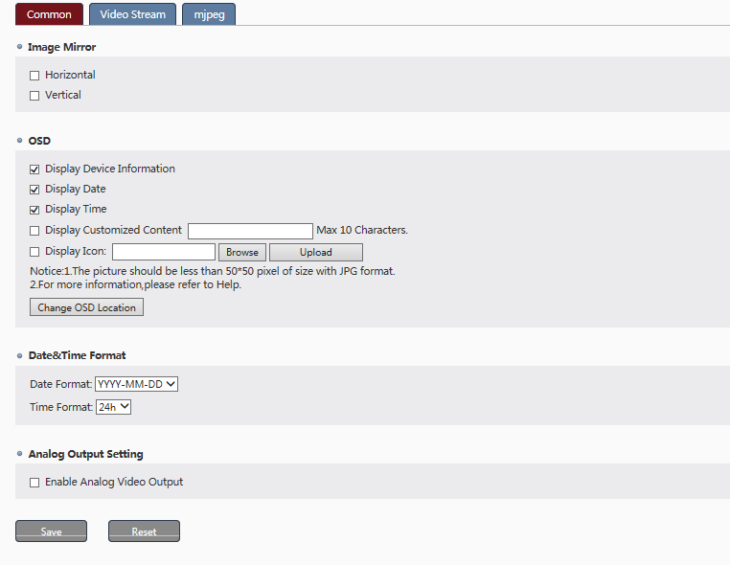
Date and time Format: Options YYYY-MM-DD, MM-DD-YYYY and DD-MM-YYYY for date format and 12h and 24h for time format. They show in the second line of the live view window in default.
Analog Output Setting: click the checkbox “enable analog video output” then image will show when the camera is connected to analog DVR. Or the analog image will be locked. This function only works when the camera hardware supports analog output.
Click Save to save your settings or click reset, to do settings again.

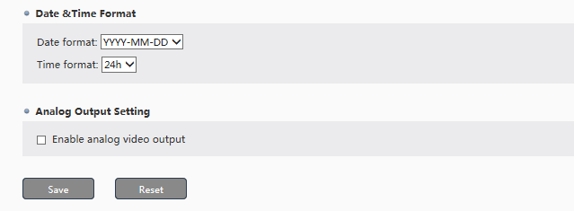

4.1.6.2 Video Stream
Encode type is always H.264.
Main stream Resolution: 5M > 4M > 3M> 1080P (2M) >960P (1.3MP) >720P (1MP).
Sub stream Resolution: D1> VGA > CIF >QCIF.
Key frame Interval: 5-100 (it means each key frame is coming after how many fps goes. 50 means after every 25fps there is 1 key frame coming. The smaller you choose, the quicker to switch from mainstream to sub stream, the higher storage need).
Bit-rate Type:
For Main Stream/Sub stream: VBR, CBR (To set bit rate should be according to limitation range, the higher the value is, the better picture quality but the higher storage is needed).
Bit rate: main stream’s bit rate is 2000~6000 kbit/s configurable for 720P/960P/1080P, 2000~8000 kbit/s configurable for 3MP/4MP/5MP. Sub stream’s bit rate is 50~1000 kbit/s configurable.
Encode Quality: 1-6 configurable (6 is the best) for VBR bit type.
Frame Rate: 1-30 or 1-25 configurable.
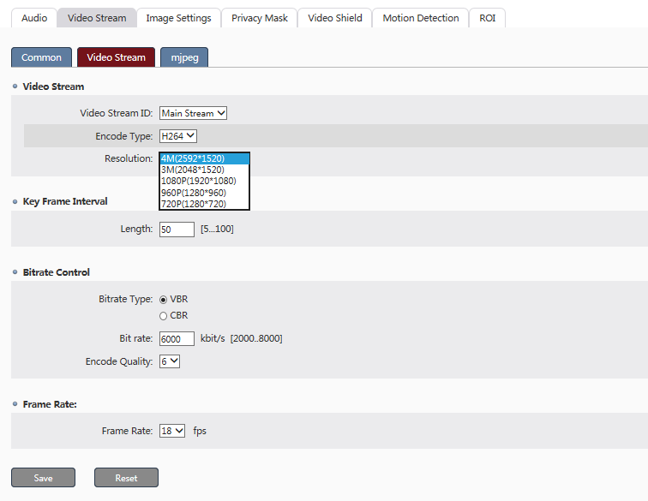

4.1.6.3 MJPEG
MJPEG:
Quality: 1-7 configurable, the larger value, the higher image quality.
Frame rate: 1-5 configurable.
Snapshot interval: 1-600s configurable.
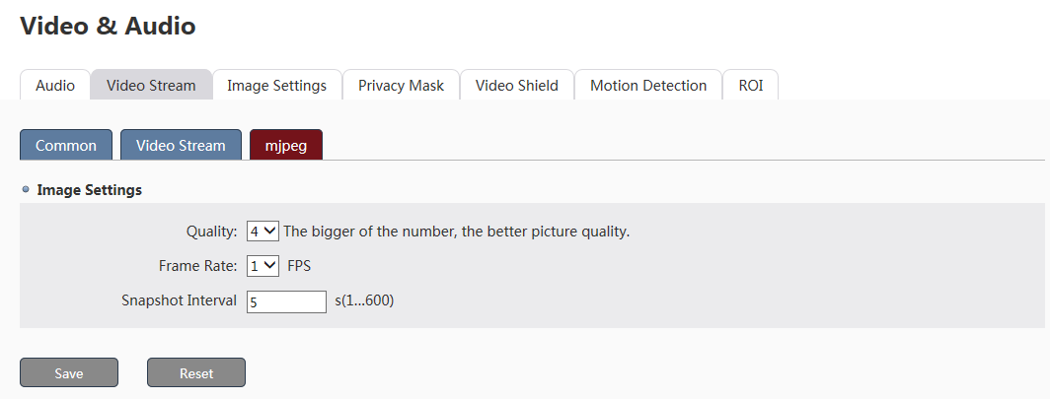

4.1.7 System
Users can find out the camera’s firmware version, hardware version, Onvif version, MAC address and serial number here.
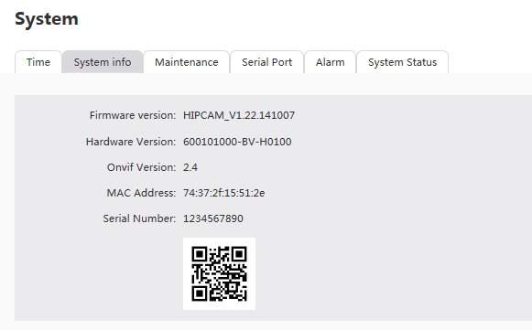

4.1.8 Maintenance
Reboot: Reboot the camera.
Default: Reset all parameters except IP to default settings.
Restore: Restore all parameters to factory settings.
Upgrade: The user can upgrade the firmware using the browsers like the IE, chrome, Firefox etc.
General: To name your device and it will show on the live video window quickly.
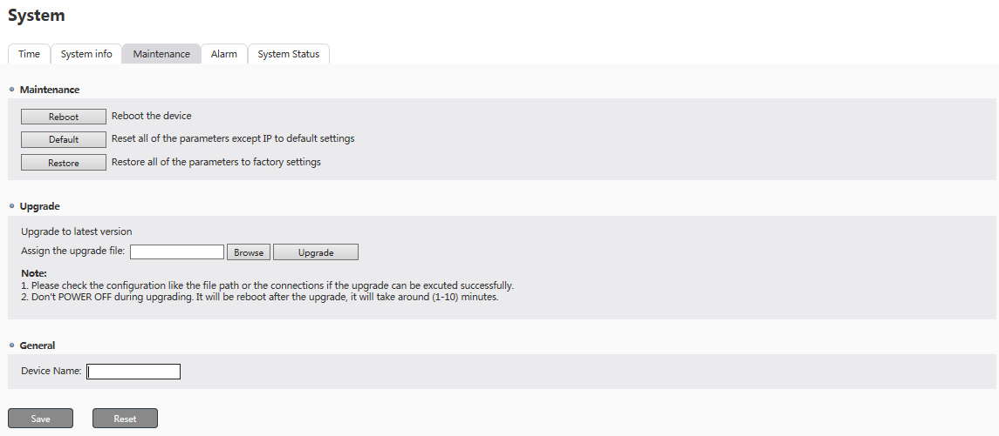

4.2 System
There are 5 tabs: time, system info, maintenance, alarm and system status.
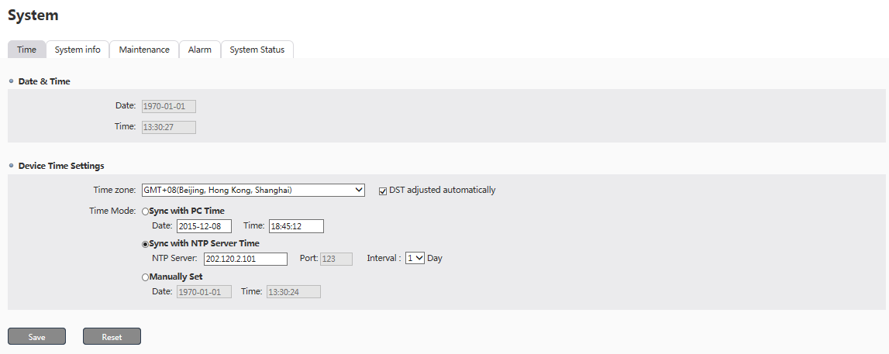

4.2.1 Time
Refer to 2.1.1 for details.

4.2.2 System Info
Refer to 2.1.7 for details.

4.2.3 Maintenance
Refer to 2.1.8 for details.
.

4.2.4 Alarm
It’s used to set alarm function. This function only works when the camera hardware supports it.
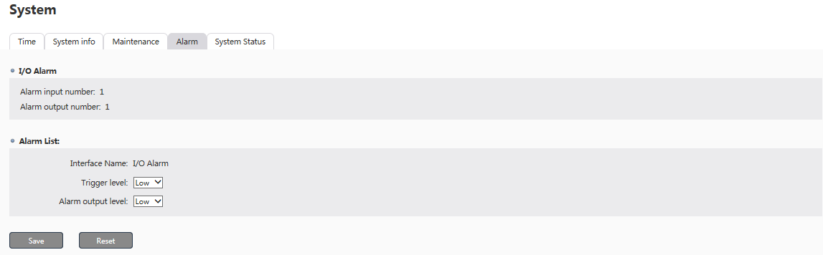

4.2.5 System Status
It shows system overview and main functions enabled/disabled.
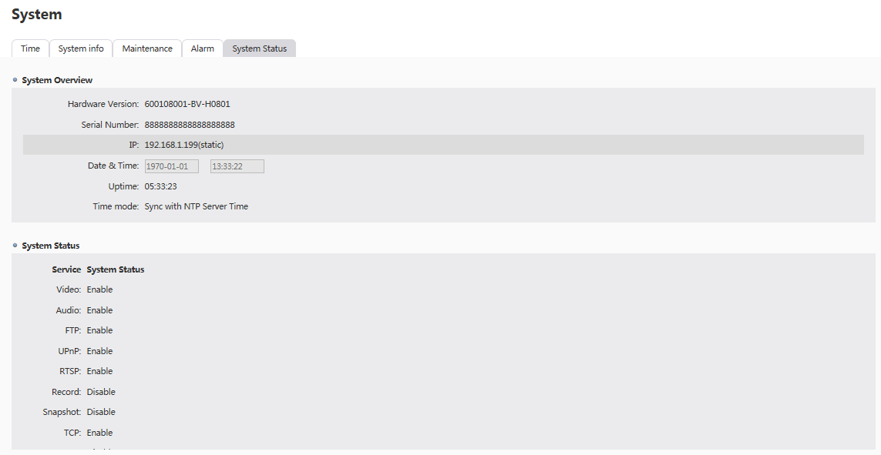

4.3 Network
There are 9 tabs: TCP/IP, Port, WIFI, FTP, PPPoE, SMTP, UPnP, RTSP, and RTMP.
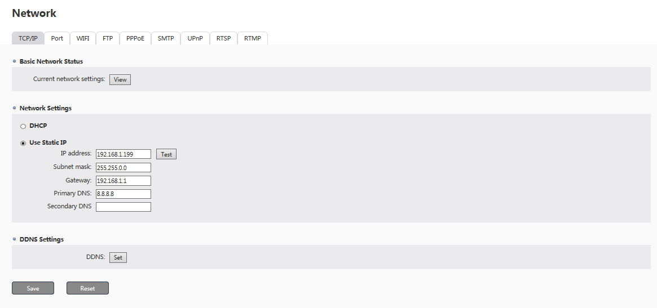

4.3.1 TCP/IP
Refer to 2.1.3 for details.

4.3.2 Port
Refer to 2.1.4 for details.

4.3.3 WIFI
WIFI parameters can be set if the device supports WIFI function.：
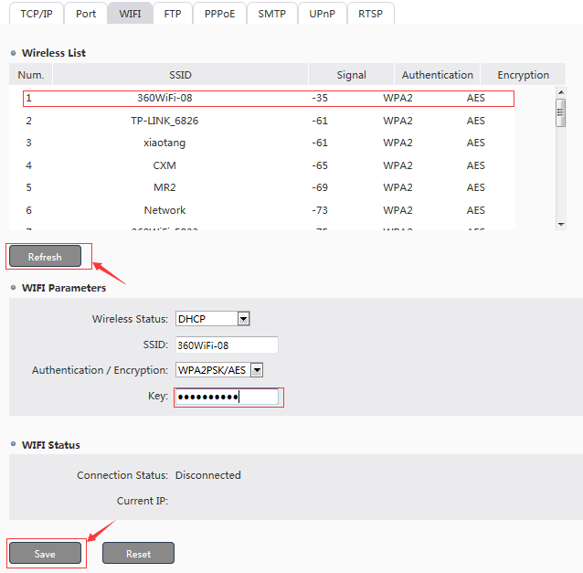
（1）Click the refresh button,the wireless network address will be listed in the table.
（2）Select the usable wireless network, Fill in the SSID and key, and select the correct Authentication/ Encryption mode.
（3）Click save button,refresh the IE,the WiFi status will be show as bellow.
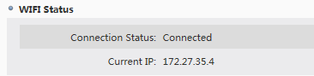
（4）You can login the IPC Using the current IP throw the wireless network.

4.3.4 FTP
Users can set FTP server’s info here.
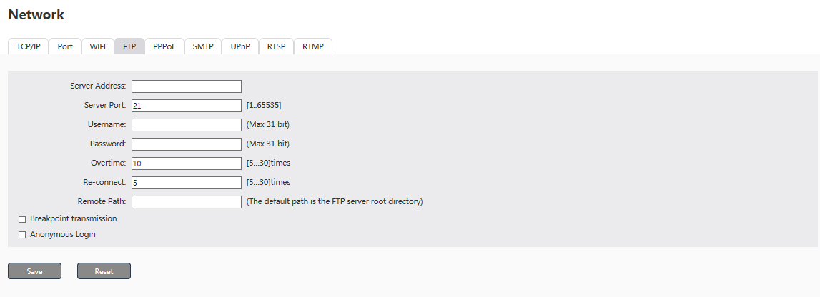

4.3.5 PPPoE
The Point-to-Point Protocol over Ethernet (PPPoE) is a network protocol for encapsulating PPP frames inside Ethernet frames. Enable PPPoE and then fill in username and password to make PPPoE function works.
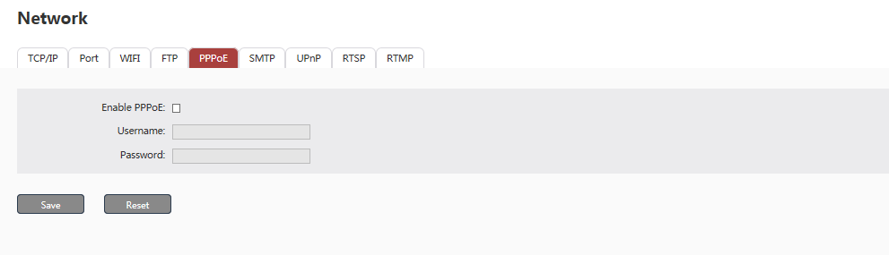

4.3.6 SMTP
Please set gateway and DNS info before SMTP settings.
Main email server: the default SMTP server.
Sub email server: when main email server is not available, sub email server will be activated.
Click the checkbox of Enable authentication to login email server, to input user name and password (if required).
Click the checkbox of SSL to enable SSL function (if required).
Type in the email address to receive test email with title of Just for Test.
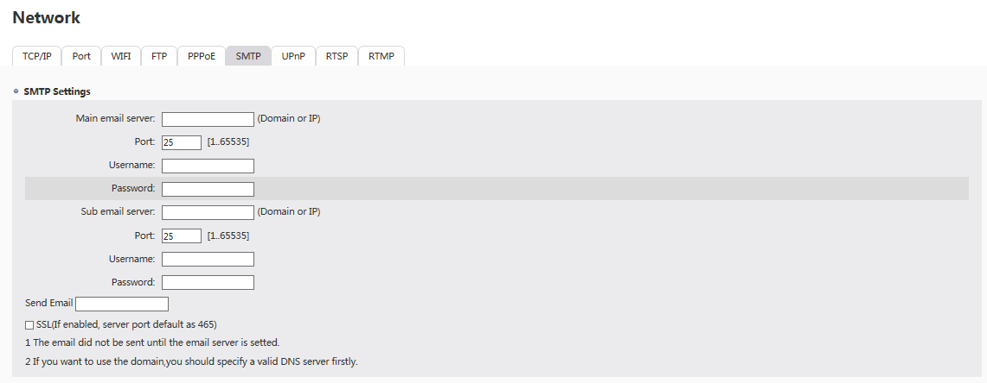
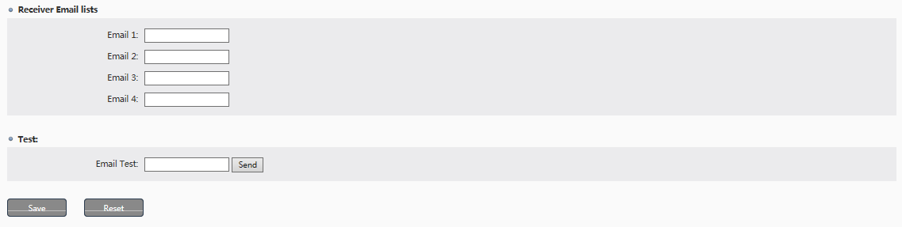

4.3.7 UPnP
This function needs Router’s support.
Camera Name: IPNC in default. Max. 20 characters.
UPnP mapping list: max. 10 mapping.
Add UPnP mapping manually: click Add then choose enable Yes, fill in internal port and external port.
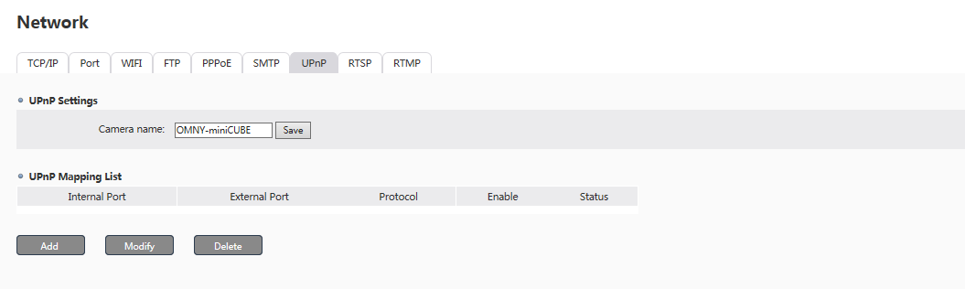
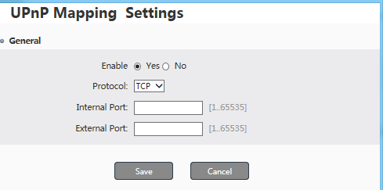

4.3.8 RTSP
The Real Time Streaming Protocol (RTSP) is a network control protocol designed for use in entertainment and communications systems to control streaming media servers. The protocol is used for establishing and controlling media sessions between end points.
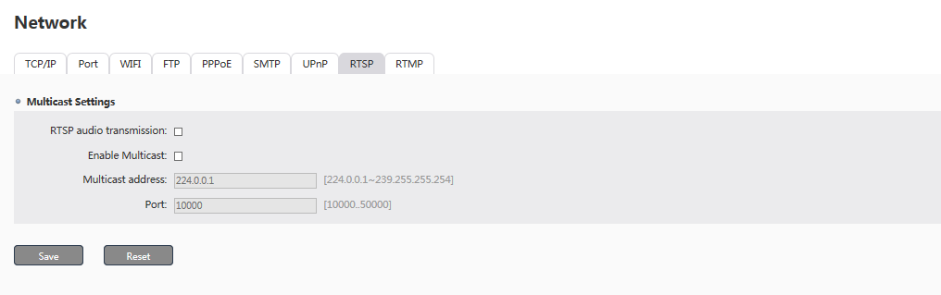

4.3.9 RTMP
Enable RTMP: Click the checkbox to enable RTMP service, it will support the camera to push the video and audio the specified server.
Time Section: the user can set the time section to schedule RTMP work time schedule.
Push type: it’s to select which stream to be push.
Push URL: it’s for the server address the video or audio was pushed to.
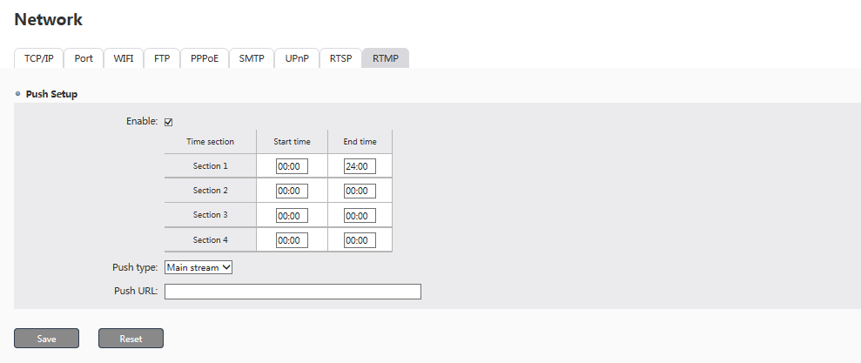

4.4 Audio & Video
There are 7 tabs: Audio, Video Stream, Image Settings, Privacy Mask, Video Shield, Motion Detection and ROI settings.
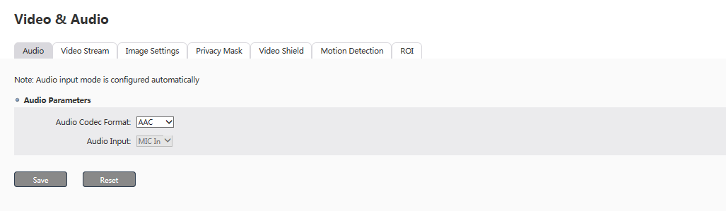

4.4.1 Audio
Please refer to 2.1.5 for details.

4.4.2 Video Stream
Please refer to 2.1.6 for details.

4.4.3 Image Setting
4.4.3.1 Image Setting
Saturation: 0-100 configurable
Brightness: 0-100 configurable
Sharpness: 0-100 configurable
Contrast: 0-100 configurable

4.4.3.2 White Balance
White Balance: Auto/Outdoor/Indoor/Sunlight Lamp

4.4.3.3 Day&Night mode
Day&Night mode: Auto/Color/B&W/Timer
- Auto mode: Color and B&W automatically switch as the light conditions.
- Audio(Inter-sync):The user can set the threshold value of the day to night, or night to day as the field condition.
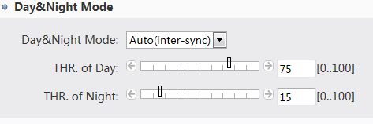
- Color: fixed color mode.
- B&W: fixed B&W mode (black and white)
- Timing mode: The user can set the work mode of the camera as the timing. For example, you can set color mode during 10:00-11:00, B&W mode during 11:00-12:00, and Auto mode from 12:00 after. If there is no setting configuration in time segment, the default mode is auto mode.
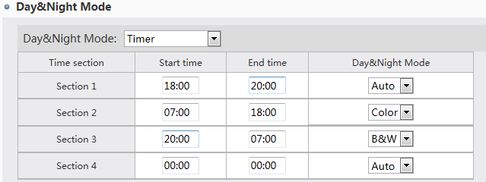

4.4.3.4 Exposure Settings:
Video Standard: 50HZ (for PAL format), 60HZ (for NTSC format)
Select the checkbox of Enable Auto Iris to enable auto iris function.
Click Live Preview to check the image.
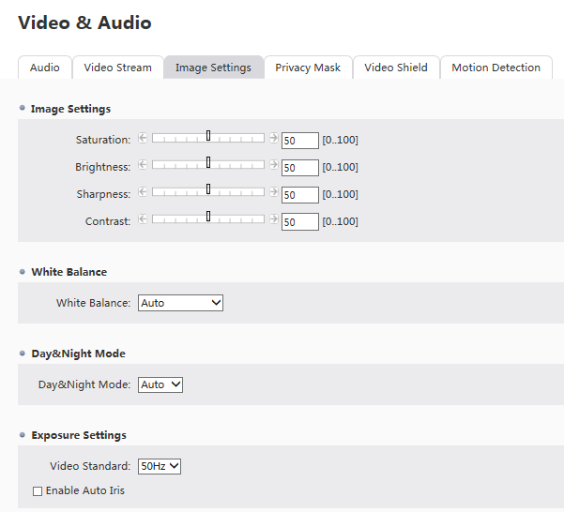
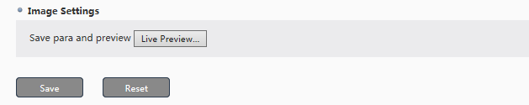

4.4.4 Privacy Mask
Max. 4 privacy zones are supported. Click Edit, draw zones by mouse and then save the zones. Click Clear to cancel all existing zones. Open/off button is for enable/disable the privacy mask function.
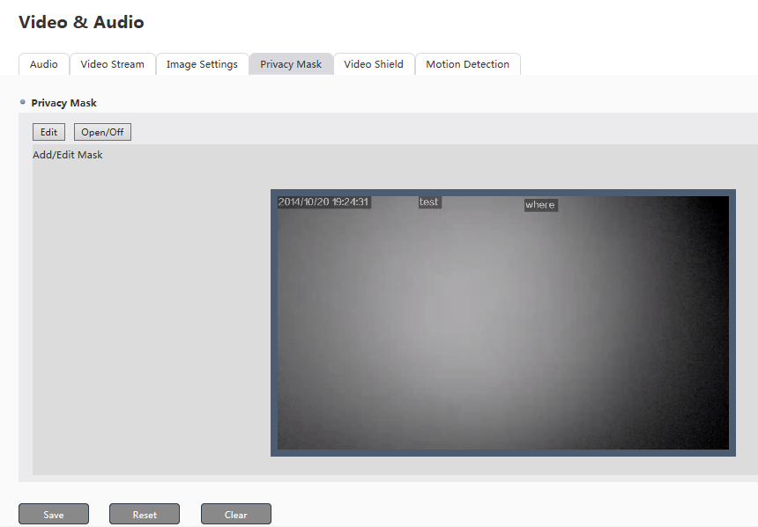

4.4.5 Video Shield
When the cameras are shielded by unidentified object, alarm info will be output if video shield function is enabled.
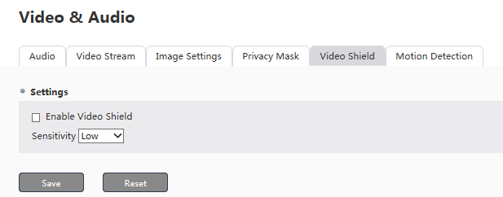

4.4.6 Motion Detection
To enable motion detection alarm, please draw zones (max. 4) by mouse and save them. Click clear to delete existing detection zones.
You can change its Sensitivity. 10 is the highest and 1 is the lowest.
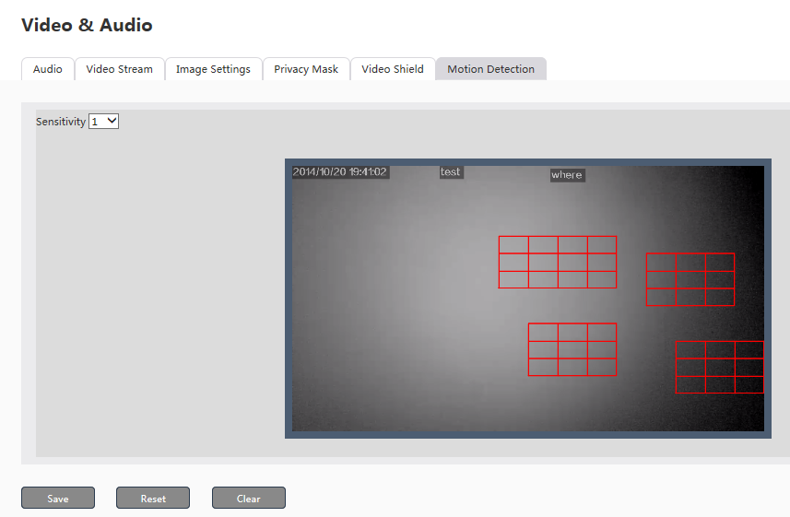

4.4.6 ROI
To enable ROI, please draw zones (max. 4) by mouse and save them. Click clear to delete existing detection zones.
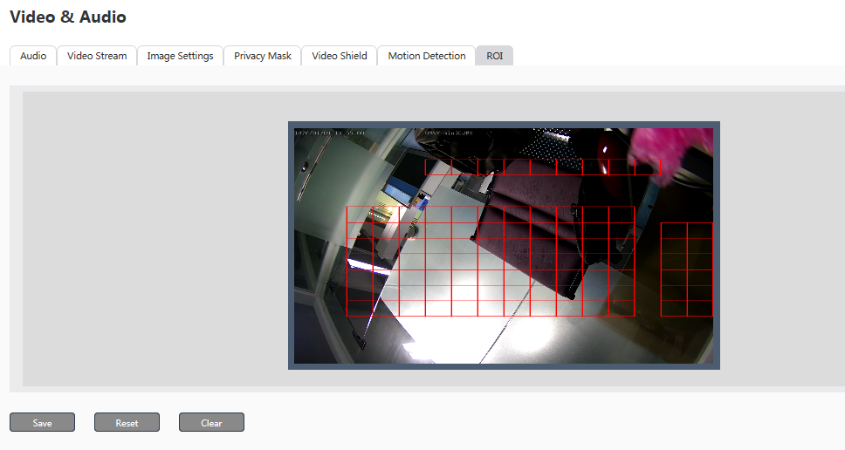

4.5 Storage

4.5.1 SD Card
SD card status and capacity will show here. Please format the SD card the first time you use it. This function only works when the camera has SD card slot.
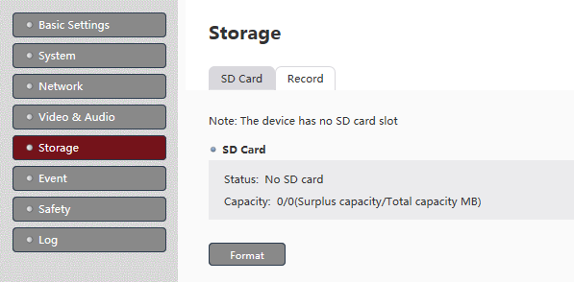

4.5.2 Record
Pre-record: 0-3 sec.
Delay-record: 0-3 sec.
Recording stream: main stream or sub stream.
SD card cycle record: while surplus capacity is lower than 256M, the camera will delete the earliest video until it exceeds 1G.
Record package: video can be stored as a package every 3 minutes, 5 minutes, or 10 minutes.
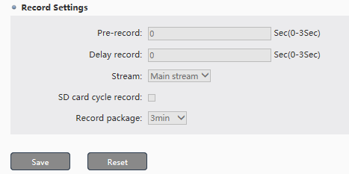

4.6 Event

4.6.1 Event Type
There are several kinds of trigger modes: I/O Alarm, motion detection device startup, video shield, network disconnect, and infrared sensors. Different alarm schedule (7*24 hours alarm, scheduled alarm, disable) and alarm response (I/O, SD card record, Send email, Send TCP notification, FTP upload, Alarm snapshot, Audio) can be set according to different trigger mode. Min. interval of trigger event can be set as 0~300 sec.
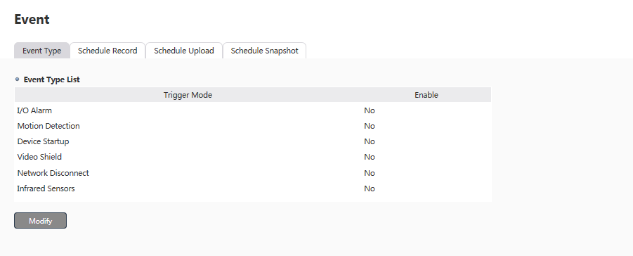
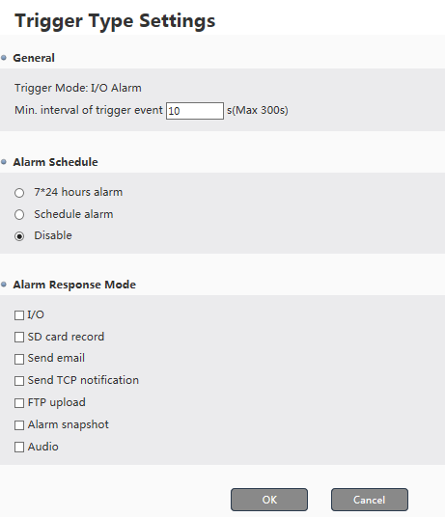

4.6.3 Schedule Record
There are 3 kinds of record plan: 7*24 hour record, schedule record and disable record. Concerning schedule record, users can set 6 segments for each day (Monday to Sunday).
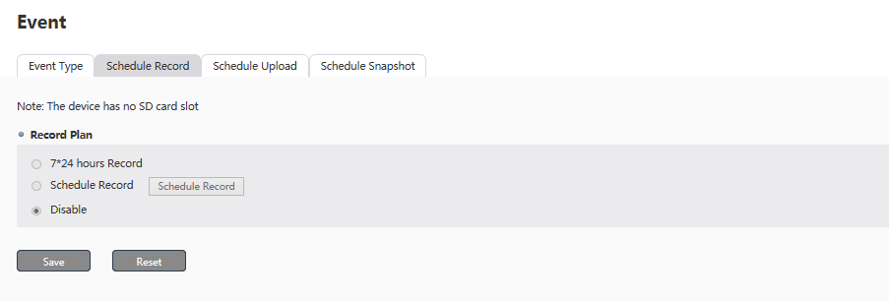

4.6.4 Schedule Upload
There are 3 kinds of upload plan: 7*24 hour upload, schedule upload and disable upload. Concerning schedule upload, users can set 6 segments for each day (Monday to Sunday).
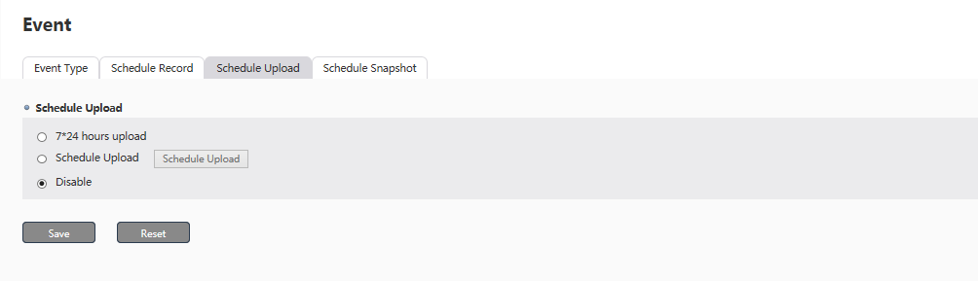

4.6.5 Schedule Snapshot
There are 3 kinds of snapshot plan: 7*24 hour snapshot, schedule snapshot and disable snapshot. Concerning schedule snapshot, users can set 6 segments for each day (Monday to Sunday).
Refer to 2.1.6.3 MJPEG for snapshot image quality, frame rate and snapshot interval, and 1.7.2 Snapshot and Record Settings for snapshot record path, response and image type (BMP or JPEG).
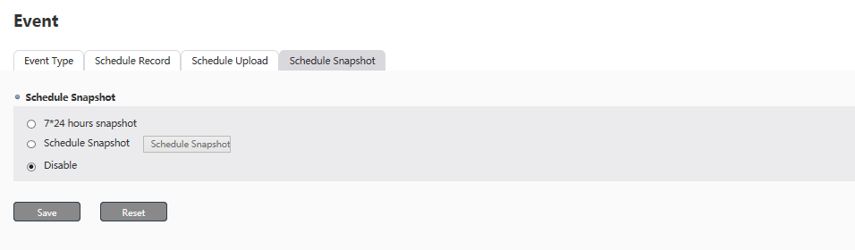

4.7 Safety

4.7.1 Users
Please refer to 2.1.2 for details.

4.7.2 IP Filtering
IP filtering function help us aviod access from certain IP addresses by setting Deny List. Click the checkbox of Enable IP Filtering, select Deny, and then add filtering IP addresses by defining start IP and end IP.
Besides, IP filtering function help us allow access only from certain IP addresses by setting Allow List. Click the checkbox of Enable IP Filtering, select Allow and then add filtering IP addresses by defining start IP and end IP.
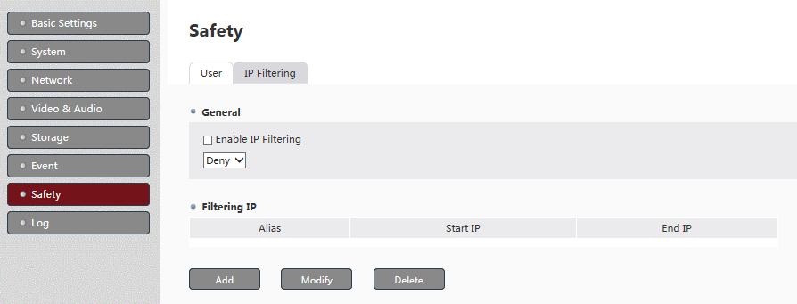
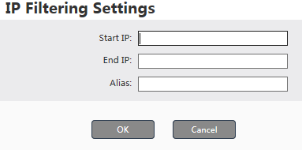

4.8 Log

4.8.1 Log Settings
Users can set saving days (10/20/30/40/50/60) for system log, alarm log and access log.
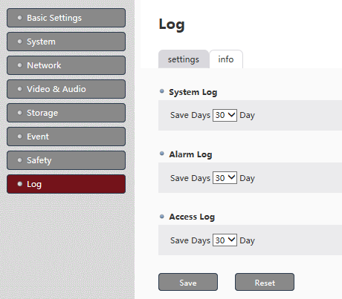

4.8.2 Log Info
Log files can help you troubleshooting. Download relative log files you need. Please note that it may take some time to download log files.
